Random Act of Kindness: Letter Style
Directions: Worldwide Kindness Day was November 13th. A random act of kindness can make someone’s day. For this assignment, you will use your knowledge of coordinating conjunctions and introductory clauses to write a letter to someone you would like to thank or appreciate.
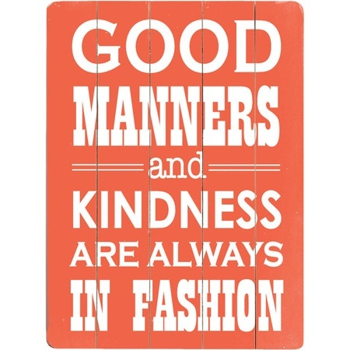
Requirements:
- Letter format in Times New Roman or Arial font size 12 or 14.
- Write 2 coordinating conjunctions.
- Write 2 introductory words/phrases.
- Consistent verb tense.

Standards:
CC.7.L.1.b Conventions of Standard English: Choose among simple, compound, complex, and compound-complex sentences to signal differing relationships among ideas
CC.7.L.1.c Conventions of Standard English: Place phrases and clauses within a sentence, recognizing and correcting misplaced and dangling modifiers.

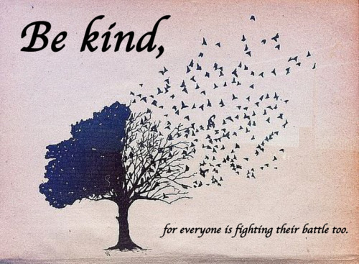

Dear Name of Recipient,

Body Paragraph 1 . . . . . . . . . . . . . . . . . . . . . . . . . . . . . . . . . . . . . . . . . . . . . . . . . . . . . . . . . . . . . . . . . . . . . . . . . . . . . . . . . . . . . . . . . . . . . . . . . . . . . . . . . . . . . . . . . . . . . . . . . . . . . . . . . . . . . . . . . . . . . . . . . . . . . . . .

Body Paragraph 2 . . . . . . . . . . . . . . . . . . . . . . . . . . . . . . . . . . . . . . . . . . . . . . . . . . . . . . . . . . . . . . . . . . . . . . . . . . . . . . . . . . . . . . . . . . . . . . . . . . . . . . . . . . . . . . . . . . . . . . . . . . . . . . . . . . . . . . . . . . . . . . . . . . . . . . . .

Body Paragraph 3 . . . . . . . . . . . . . . . . . . . . . . . . . . . . . . . . . . . . . . . . . . . . . . . . . . . . . . . . . . . . . . . . . . . . . . . . . . . . . . . . . . . . . . . . . . . . . . . . . . . . . . . . . . . . . . . . . . . . . . . . . . . . . . . . . . . . . . . . . . . . . . . . . . . . . . . .

Closing (Sincerely...),

Signature

Letter Rubric
 | 4 | 3 | 2 | 1
Comma Rules  x2 | There are 2 coordinating conjunctions and 2 introductory clauses comma rules used correctly. | There are three sentences of the comma rules mentioned used correctly. | There are two sentences of the comma rules mentioned used correctly. | There are two sentences of the comma rules mentioned used correctly.
Support | It is evident the writer put much thought into this assignment. Has three paragraphs relating to the topic. | It is evident the writer put some thought into this assignment. Has two paragraphs relating to the topic. | It is evident the writer put some thought into this assignment. Has one paragraphs relating to the topic. | It is evident the writer put little to no thought into this assignment. Has no paragraphs relating to the topic.
Organization | Sentences and paragraphs are complete, well written, and varied. | Sentence and paragraph structure is generally correct. | Sentence and paragraph structure is inconsistent. | Little or no evidence of sentence or paragraph structure.
Word Choice/Verb Tense | Choice of words that are clear, descriptive, and accurate. Maintains consistent verb tense throughout letter. | Adequate choice of words that are clear and descriptive. Demonstrates consistent verb tense in parts of the letter. | Choice of some words that are clear and descriptive. Lacks consistent verb tense. | Language and tone of letter is unclear and lacks description.
Format |  |  | Is in Times New Roman or Arial size 12 or 14 font. | Is not in Times New Roman or Arial size 12 or 14 font.
Mechanics and Grammar | Contains few(0-2), if any punctuation, capitalization, spelling, or grammatical errors. | Contains several(3-4) errors in punctuation, capitalization, spelling, or grammar that do not interfere with meaning. | Contains many(5+) punctuation, spelling, and/or grammatical errors that interfere with meaning. | Contains many punctuation, spelling, and/or grammatical errors that make the piece illegible.

/26

