Dear Luna,

I just wanted to take the time to tell you how important you are to me. I know I haven’t been home as much as you would like, but you mean the world to me. I can’t imagine a day without you and your love for string and the litter box. It seems way longer than that fateful day in July when the shelter handed me a black ball of fur.

You might not be the most behaved kitten in the world, but I love you. Remember that one time you batted several glittery ornaments off the tree? Still loved you then. Remember those times you tried to eat the insulation off the windows? Yep, still loved you then and forever. No matter how many times you try to steal my food, I will be looking out for you.

In addition, you have the strangest, cutest quirks. Whenever you are on the counter, which you are not supposed to be, you hide in the corner thinking I can’t see you. After grading at night, I often glance into the kitchen and see your head pop out of the sink. You are very strange, yet so easy to love. I hope you know this.

Sincerely,

Ms. Janacek

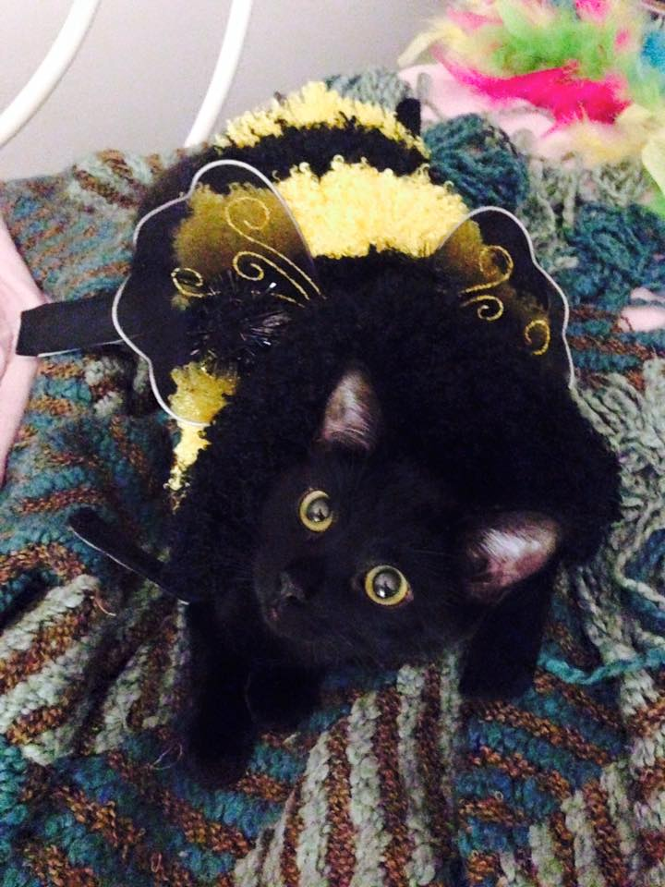
P.S. Thanks for letting me dress you up, and it’s awesome how much you enjoy it.

