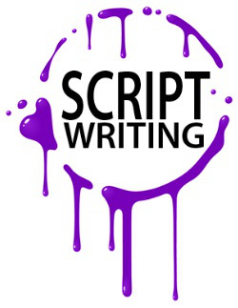
Digital Story Script
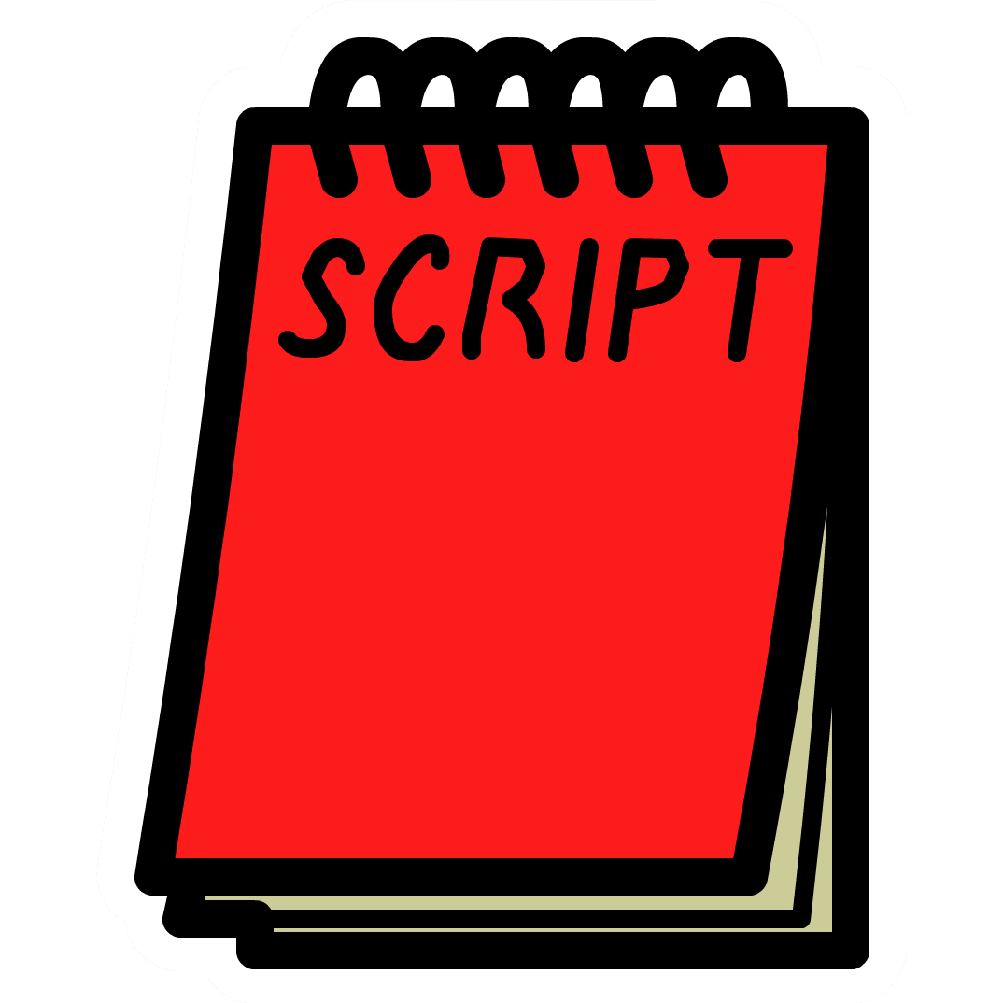
When writing your script you have two options.
- Use a variety of images to help tell your story with your voice or other sound effects in the background.
- Record and act out what is going on in your story.
Once you pick the option you want to go with, then you will start writing your script. Examples of scripts are on Google Classroom under our R.H.S.W.
Instructions for writing a script:
- Under this assignment, add a Google Document on Google Classroom.
- On the top left hand corner of the document write your heading in Times New Roman or Arial font size 12 or 14.
- Under your heading, click on the center button and add your title.
- Under your title, write “Setting:” and describe the setting of your first scene in your story. Each time you switch settings, describe your new setting.
- Whenever you have a speaker talking, write the name of the speaker and then what they are going to say. For example,
KRISTOFF
I’ll tell you why. We need Elsa to bring back summer.
OLAF
(shocked) Summer? (sinking into wistfulness) Oh, I don’t know why but I’ve always loved the idea of summer, and sun, and all things hot.

KRISTOFF
Really? I’m guessing you don’t have much experience with heat.
or
KRISTOFF: I’ll tell you why. We need Elsa to bring back summer.
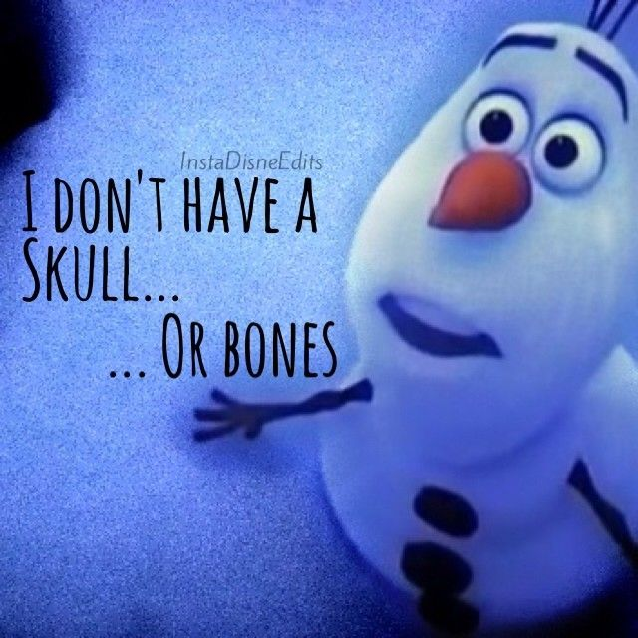
OLAF: (shocked) Summer? (sinking into wistfulness) Oh, I don’t know why but I’ve always loved the idea of summer, and sun, and all things hot.
KRISTOFF: Really? I’m guessing you don’t have much experience with heat.

- Whenever a new speaker is talking, they get their own line. Add details about the character.
- Start writing.

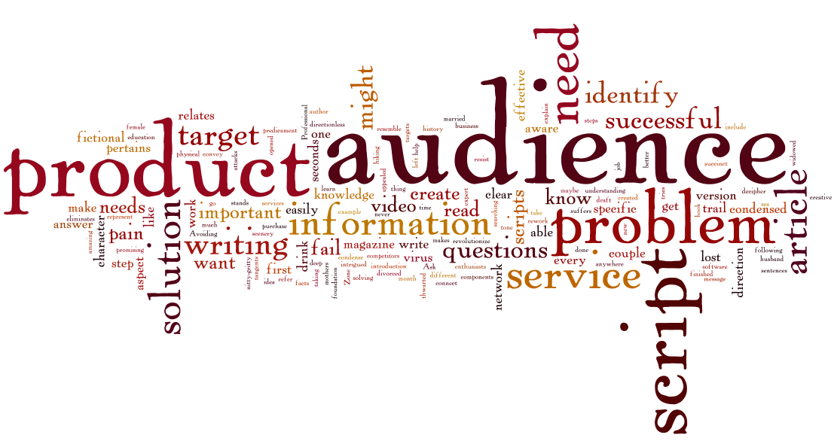

Script Rubric
 | 4 | 3 | 2 | 1
Grammar & Spelling (Conventions) | Writer makes 1-2 errors in grammar or spelling. | Writer makes 3-4 errors in grammar or spelling. | Writer makes 5-6 errors in grammar or spelling. | Writer makes more than 6 errors in grammar or spelling.
Written in Script Format  x2 | The script is written in the correct format. All lines have the correct font, font size, punctuation. and header. | The script is mostly correct. Either the font and font size OR punctuation is incorrect. | The script is slightly correct. Both the font, font size, and punctuation is incorrect. | The script is NOT written in script format.
Easy to Understand & Follow  x2 | Script is easy for a reader to understand and follow. It flows and makes sense. | Script has parts that are confusing but the overall intention is clear. | Script is difficult to read and understand. It does not flow. An attempt has been made. | Script does NOT make sense. Reader can not follow or understand the intention or where the script is going.
Creativity  x2 | The story contains many creative details and/or descriptions that contribute to the reader’s enjoyment. The author has really used his/her imagination. | The story contains a few creative details and/or descriptions that contribute to the reader’s enjoyment. The author has used his/her imagination. | The story contains a few creative details and/or descriptions, but they distract from the story. The author has tried to use his/her imagination. | There is little evidence of creativity in the story. The author does not seem to have used much imagination.
/28

